**DIGITAL ASSIGNMENT – 2**

Name: Gagan Chordia

Reg. No: 19BCE0788

Course: Operating Systems

Slot: L9+L10

**Questions from Previous DA**

1. Assume that two processes named client and server running in the system. It is required that these

two processes should communicate with each other using shared memory concept. The server

writes alphabets from a..z to the shared memory .the client should read the alphabets from the

shared memory and convert it to A...Z. Write a program to demonstrate the above mentioned

scenario.

Server C Code:

#include <sys/types.h>

#include <sys/ipc.h>

#include <sys/shm.h>

#include <stdio.h>

#include<stdlib.h>

#define SHMSZ 27

void main(){

char c;

int shmid;

key_t key;

char *shm, *s;

key = 5678;

if ((shmid = shmget(key, SHMSZ, IPC_CREAT | 0666)) < 0) {

perror("shmget");

exit(1);

}

if ((shm = shmat(shmid, NULL, 0)) == (char *) -1) {

perror("shmat");

exit(1);

}

s = shm;

printf("Writing ");

for (c = 'a'; c <= 'z'; c++){

printf("%c",c);

*s++ = c;

}

printf("\n");

*s = NULL;

while (*shm != '*'){

sleep(1);

}

exit(0);

}

Server Output:

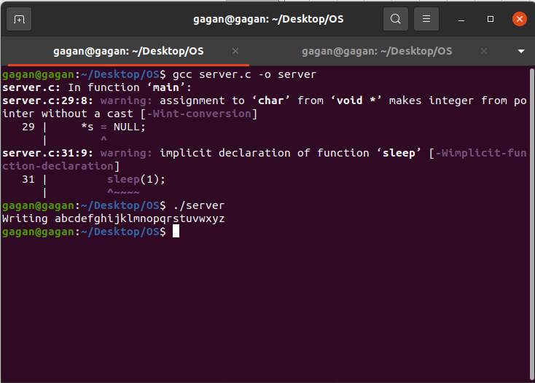

Client C Code:

#include <sys/types.h>

#include <sys/ipc.h>

#include <sys/shm.h>

#include <stdio.h>

#include<stdlib.h>

#define SHMSZ 27

void main(){

int shmid;

key_t key;

char *shm, *s;

key = 5678;

if ((shmid = shmget(key, SHMSZ, 0666)) < 0) {

perror("shmget");

exit(1);

}

if ((shm = shmat(shmid, NULL, 0)) == (char *) -1) {

perror("shmat");

exit(1);

}

printf("Reading ");

for (s = shm; *s != NULL; s++){

putchar(toupper(*s));

}

putchar('\n');

*shm = '*';

exit(0);

}

Client Output:

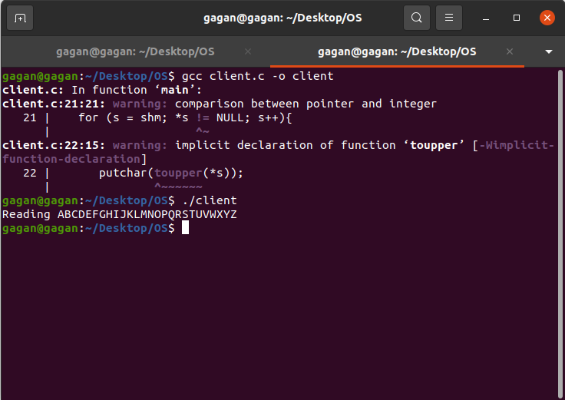

**Current DA**

1. FCFS

C Code:

#include<stdio.h>

int main(){

int n, burstTime[5], waitingTime[5], turnAroundTime[5], avgWaitingTime = 0, avgTurnAroundTime = 0, i, j;

printf("Enter total number of processes:");

scanf("%d",&n);

printf("\nEnter Process Burst Time\n");

for(i = 0; i < n; i++){

printf("Process[%d]:",i+1);

scanf("%d",&burstTime[i]);

}

waitingTime[0] = 0;

for(i = 1; i < n; i++){

waitingTime[i] = 0;

for(j = 0; j < i; j++)

waitingTime[i] += burstTime[j];

}

printf("\nProcess\t\tBurst Time\tWaiting Time\tTurnaround Time");

for(i=0;i<n;i++){

turnAroundTime[i] = burstTime[i] + waitingTime[i];

avgWaitingTime += waitingTime[i];

avgTurnAroundTime += turnAroundTime[i];

printf("\nProcess[%d]\t\t%d\t\t%d\t\t%d",i+1, burstTime[i], waitingTime[i], turnAroundTime[i]);

}

avgWaitingTime /= n;

avgTurnAroundTime /= n;

printf("\n\nAverage Waiting Time:%d", avgWaitingTime);

printf("\nAverage Turnaround Time:%d\n", avgTurnAroundTime);

return 0;

}

Output:

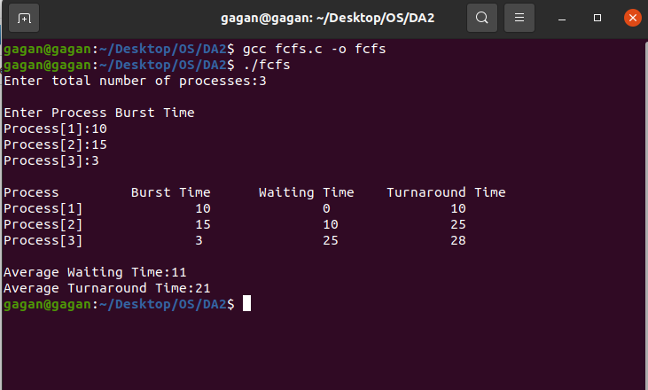

2. SJF

C Code:

#include<stdio.h>

int main(){

int burstTime[5],process[5], waitingTime[5], turnAroundTime[5], i, j, n, total = 0, pos, temp, avgWaitingTime, avgTurnAroundTime;

printf("Enter number of process:");

scanf("%d",&n);

printf("\nEnter Burst Time: ");

for(i = 0;i < n;i++){

printf("\nProcess[%d]:",i+1);

scanf("%d",&burstTime[i]);

process[i] = i + 1;

}

//sorting of burst times

for(i = 0;i < n;i++){

pos = i;

for(j = i + 1;j < n;j++){

if(burstTime[j] < burstTime[pos])

pos = j;

}

temp = burstTime[i];

burstTime[i] = burstTime[pos];

burstTime[pos] = temp;

temp = process[i];

process[i] = process[pos];

process[pos] = temp;

}

waitingTime[0] = 0;

for(i = 1;i < n;i++){

waitingTime[i] = 0;

for(j = 0;j < i;j++)

waitingTime[i] += burstTime[j];

total += waitingTime[i];

}

avgWaitingTime = total / n;

total = 0;

printf("\nProcess\t\tBurst Time\t\tWaiting Time\tTurnaround Time");

for(i = 0;i < n;i++){

turnAroundTime[i] = burstTime[i] + waitingTime[i];

total += turnAroundTime[i];

printf("\nProcess%d\t\t%d\t\t%d\t\t%d", process[i], burstTime[i], waitingTime[i], turnAroundTime[i]);

}

avgTurnAroundTime = total / n;

printf("\n\nAverage Waiting Time = %d",avgWaitingTime);

printf("\nAverage Turnaround Time = %d\n",avgTurnAroundTime);

}

Output:

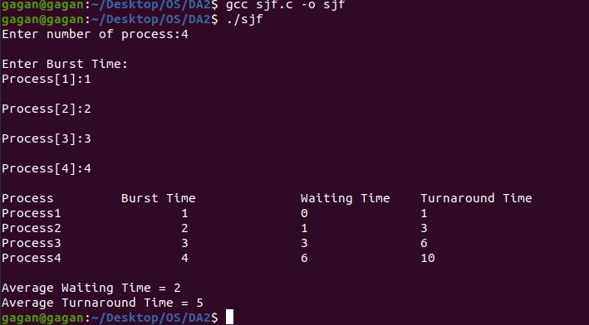

3. Round Robin

C Code:

#include<stdio.h>

int main(){

int i, n, total = 0, x, counter = 0, timeQuantum;

int waitingTime = 0, turnAroundTime = 0, arrivalTime[5], burstTime[5], temp[5];

int avgWaitingTime, avgTurnAroundTime;

printf("Enter Number of Processes: ");

scanf("%d", &n);

x = n;

for(i = 0; i < n; i++){

printf("Process[%d]\n", i + 1);

printf("Arrival Time: ");

scanf("%d", &arrivalTime[i]);

printf("Burst Time: ");

scanf("%d", &burstTime[i]);

temp[i] = burstTime[i];

}

printf("\nEnter Time Quantum: ");

scanf("%d", &timeQuantum);

printf("\nProcess ID\t\tBurst Time\t Turnaround Time\t Waiting Time\n");

for(total = 0, i = 0; x != 0;){

if(temp[i] <= timeQuantum && temp[i] > 0){

total = total + temp[i];

temp[i] = 0;

counter = 1;

}

else if(temp[i] > 0){

temp[i] = temp[i] - timeQuantum;

total = total + timeQuantum;

}

if(temp[i] == 0 && counter == 1){

x--;

printf("\nProcess[%d]\t\t%d\t\t %d\t\t\t %d", i + 1, burstTime[i], total - arrivalTime[i], total - arrivalTime[i] - burstTime[i]);

waitingTime = waitingTime + total - arrivalTime[i] - burstTime[i];

turnAroundTime = turnAroundTime + total - arrivalTime[i];

counter = 0;

}

if(i == n - 1){

i = 0;

}

else if(arrivalTime[i + 1] <= total){

i++;

}

else{

i = 0;

}

}

avgWaitingTime = waitingTime / n;

avgTurnAroundTime = turnAroundTime / n;

printf("\n\nAverage Waiting Time: %d", avgWaitingTime);

printf("\nAvg Turnaround Time: %d\n", avgTurnAroundTime);

return 0;

}

Output:

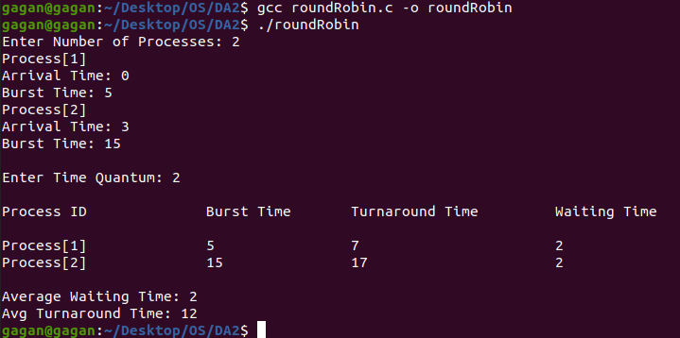

4. Priority

C Code: Non Preemptive

#include<stdio.h>

int main(){

int burstTime[5], process[5], waitingTime[5], turnAroundTime[5], priority[5];

int i, j, n, total = 0, position, temp;

int avgWaitingTime, avgTurnAroundTime;

printf("Enter number of Processes: ");

scanf("%d", &n);

printf("Enter Burst Time and Priority For %d Processes\n", n);

for(i = 0; i < n; i++){

printf("Process[%d]\n", i + 1);

printf("Process Burst Time: ");

scanf("%d", &burstTime[i]);

printf("Process Priority: ");

scanf("%d", &priority[i]);

process[i] = i + 1;

}

for(i = 0; i < n; i++){

position = i;

for(j = i + 1; j < n; j++){

if(priority[j] < priority[position]){

position = j;

}

}

temp = priority[i];

priority[i] = priority[position];

priority[position] = temp;

temp = burstTime[i];

burstTime[i] = burstTime[position];

burstTime[position] = temp;

temp = process[i];

process[i] = process[position];

process[position] = temp;

}

waitingTime[0] = 0;

for(i = 1; i < n; i++)

{

waitingTime[i] = 0;

for(j = 0; j < i; j++)

{

waitingTime[i] = waitingTime[i] + burstTime[j];

}

total += waitingTime[i];

}

avgWaitingTime = total / n;

total = 0;

printf("\nProcess ID\t\tBurst Time\t Waiting Time\t Turnaround Time\n");

for(i = 0; i < n; i++)

{

turnAroundTime[i] = burstTime[i] + waitingTime[i];

total += turnAroundTime[i];

printf("\nProcess[%d]\t\t%d\t\t %d\t\t %d\n", process[i], burstTime[i], waitingTime[i], turnAroundTime[i]);

}

avgTurnAroundTime = total / n;

printf("\n\nAverage Waiting Time: %d", avgWaitingTime);

printf("\nAverage Turnaround Time: %d\n", avgTurnAroundTime);

return 0;

}

Output:

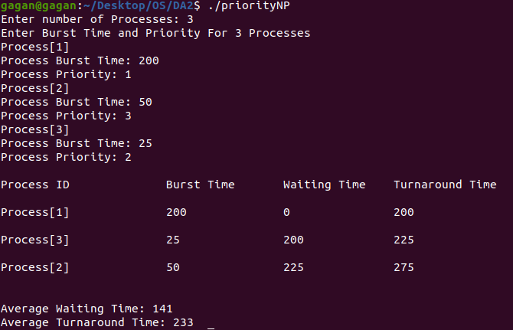

C Code: Preemptive

#include<stdio.h>

struct process

{

char processName;

int arrivalTime, burstTime, ct, waitingTime, turnAroundTime, priority;

int status;

}processQueue[5];

int n;

void ArrivalTimeSorting()

{

struct process temp;

int i, j;

for(i = 0; i < n - 1; i++)

{

for(j = i + 1; j < n; j++)

{

if(processQueue[i].arrivalTime > processQueue[j].arrivalTime)

{

temp = processQueue[i];

processQueue[i] = processQueue[j];

processQueue[j] = temp;

}

}

}

}

int main()

{

int i, time = 0, burstTime = 0, largest;

char c;

float waitingTime = 0, turnAroundTime = 0, avgWaitingTime, avgTurnAroundTime;

printf("\nEnter Total Number of Processes:\t");

scanf("%d", &n);

for(i = 0, c = 'A'; i < n; i++, c++)

{

processQueue[i].processName = c;

printf("\nEnter Details For Process[%C]:\n", processQueue[i].processName);

printf("Enter Arrival Time:\t");

scanf("%d", &processQueue[i].arrivalTime );

printf("Enter Burst Time:\t");

scanf("%d", &processQueue[i].burstTime);

printf("Enter Priority:\t");

scanf("%d", &processQueue[i].priority);

processQueue[i].status = 0;

burstTime += processQueue[i].burstTime;

}

ArrivalTimeSorting();

processQueue[4].priority = -9999;

printf("\nProcess Name\tArrival Time\tBurst Time\tPriority\tWaiting Time");

for(time = processQueue[0].arrivalTime; time < burstTime; time++)

{

largest = 4;

for(i = 0; i < n; i++)

{

if(processQueue[i].arrivalTime <= time && processQueue[i].status != 1 && processQueue[i].priority > processQueue[largest].priority)

{

largest = i;

}

}

time += processQueue[largest].burstTime;

processQueue[largest].ct = time;

processQueue[largest].waitingTime = processQueue[largest].ct - processQueue[largest].arrivalTime - processQueue[largest].burstTime;

processQueue[largest].turnAroundTime = processQueue[largest].ct - processQueue[largest].arrivalTime;

processQueue[largest].status = 1;

waitingTime = waitingTime + processQueue[largest].waitingTime;

turnAroundTime = turnAroundTime + processQueue[largest].turnAroundTime;

printf("\n%c\t\t%d\t\t%d\t\t%d\t\t%d", processQueue[largest].processName, processQueue[largest].arrivalTime, processQueue[largest].burstTime, processQueue[largest].priority, processQueue[largest].waitingTime);

}

avgWaitingTime = waitingTime / n;

avgTurnAroundTime = turnAroundTime / n;

printf("\n\nAverage waiting time:\t%f\n", avgWaitingTime);

printf("Average Turnaround Time:\t%f\n", avgTurnAroundTime);

return 0;

}

Output: (Ran in Windows due to unknown errors in Ubuntu)

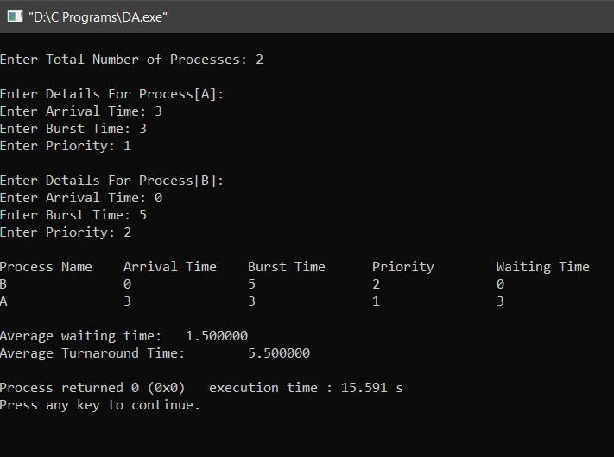

Bankers Algorithm

C Code:

#include <stdio.h>

#include <stdlib.h>

int main()

{

int max[10][10], need[10][10], alloc[10][10], avail[10], completed[10], safeSequence[10];

int p, r, i, j, process, count;

count = 0;

printf("Enter number of processes : ");

scanf("%d", &p);

for(i = 0; i< p; i++)

completed[i] = 0;

printf("\n\nEnter the no of resources : ");

scanf("%d", &r);

printf("\n\nEnter the Max Matrix for each process : ");

for(i = 0; i < p; i++)

{

printf("\nFor process %d : ", i + 1);

for(j = 0; j < r; j++)

scanf("%d", &max[i][j]);

}

printf("\n\nEnter the allocation for each process : ");

for(i = 0; i < p; i++)

{

printf("\nFor process %d : ",i + 1);

for(j = 0; j < r; j++)

scanf("%d", &alloc[i][j]);

}

printf("\n\nEnter the Available Resources : ");

for(i = 0; i < r; i++)

scanf("%d", &avail[i]);

for(i = 0; i < p; i++)

for(j = 0; j < r; j++)

need[i][j] = max[i][j] - alloc[i][j];

do

{

printf("\n Max matrix:\tAllocation matrix:\n");

for(i = 0; i < p; i++)

{

for( j = 0; j < r; j++)

printf("%d ", max[i][j]);

printf("\t\t");

for( j = 0; j < r; j++)

printf("%d ", alloc[i][j]);

printf("\n");

}

process = -1;

for(i = 0; i < p; i++)

{

if(completed[i] == 0)

{

process = i ;

for(j = 0; j < r; j++)

{

if(avail[j] < need[i][j])

{

process = -1;

break;

}

}

}

if(process != -1)

break;

}

if(process != -1)

{

printf("\nProcess %d runs to completion!", process + 1);

safeSequence[count] = process + 1;

count++;

for(j = 0; j < r; j++)

{

avail[j] += alloc[process][j];

alloc[process][j] = 0;

max[process][j] = 0;

completed[process] = 1;

}

}

}

while(count != p && process != -1);

if(count == p)

{

printf("\nThe system is in a safe state\n");

printf("Safe Sequence : ");

for( i = 0; i < p; i++)

printf("%d ", safeSequence[i]);

printf("\n");

}

else

printf("\nThe system is in an unsafe state");

}

Output:

